Guidelines for TCLT13 Full Paper Submission
(TCLT13 会议论文全文提交体例说明)

Proceedings Editors
(会议论文编辑)
TCLT13 Organizing Committee
（会议组织委员会）
TCLT13@tclt.us

1. Disclaimer and Copyright Statement

Individual author (not TCLT or TCLT13 sponsoring institutions and organizers) is responsible for the proper handling of any copyright issues related to his/her paper. The author agrees that his/her paper:

- is the author's original work;
- has not been published elsewhere;
- does not infringe the copyright or property rights of others; and
- contains no materials that is unlawful or violates others' civil rights or rights of privacy.

2. About This Document

This document provides general guidelines for preparing your TCLT13 full paper. Please use the sample Word files (TCLT13SampleEnglish.docx for paper in English and TCLT13SampleChinese.docx for paper in Chinese) for additional instructions. Three groups of screen captures are also included at the end of this document for your reference.

3. Language
English or Chinese

4. Length
No more than 8 pages (single spaced) including references and appendices. If you do need to exceed the 8-page limit, please contact us at editor@tclt.us.

5. File Format

Name your two submissions as follows:

Lastname_Firstname_A_couple_of_Keywords.docx
Lastname_Firstname_A_couple_of_Keywords.pdf

- Word document format: Both .doc and .docx are acceptable
- PDF format: This helps us identify any rare characters, symbols, and paper layout
6. Style Settings

The following provides general guidelines for text formatting. For additional information, please refer to the two sample files, respectively.

6.1 Typography settings in Word

If your paper is in Chinese, please refer to the typography screen capture (Appendix 1) to adjust the Typology settings of your Word so that the first and last characters of each line can be taken care of properly.

6.2 Paper size and margins

Paper size: Letter (8.5" x 11")
Margins: Top: 1", Bottom: 1", Left: 1.25", Right: 1.25"
See the Document Format settings in Appendix 2.

6.3 Font size

- Paper title: 16pt, bold
- Body of text (including section and subsection titles): 12pt
- Footnote, table and image captions: 10pt

6.4 Font type

- Chinese
  - Simplified or traditional Chinese characters at the author’s preference
    - Microsoft Windows, English version: SimSun,
    - Microsoft Windows, Chinese version: 宋体, 小四号 or similar if using Traditional Chinese Windows
    - Macintosh: Song
  - Embedded English text in Chinese paper
    - English text is to be set in Times New Roman
- English
  - Times New Roman
  - Embedded Chinese in English paper
    - Follow the above specifications for Chinese font type

6.5 Header/footer

No header or footer

6.6 Footnotes

- Use footnotes instead of endnotes. Number footnotes consecutively.
- Font size: 10pt
- Font type: Same as body of the text

6.7 Page number

No page numbers are to be inserted.

6.8 Spacing

- Single space
- Between paragraphs: add 12pt blank space
- Between sections: add 24pt blank space

Please refer to the Paragraph Format settings shown in Appendix 3 for instructions about setting up white space after each paragraph. Do not use multiple returns between paragraphs.

6.9 Alignment

- Title and contact info: Centered
- Abstracts and keywords: Indent paragraphs 0.5 inch on both margins
- Body of text:
  - Indent 0.5" to left margin of first line of each paragraph if Paper is in English, or 2 characters (0.33") for paper in Chinese
  - Justify all paragraphs
- Reference:
  - Indent 0.5" to left margin of the second line, not the first.

6.10 Numbering sections and subsections
Use numerals to number all sections and subsections. Add a period (.) after the numeral for the section title. Do not use a following period (.) for subsection titles. Leave a (English) blank space between numerals and section or subsection title. Examples are given below.

1. Section Title Goes Here
1.1 This is the first subsection of Section 1
1.2 This is the second subsection of Section 1
1.2.1 This is the first subsection of Section 1.2
1.2.1 This is the second subsection of Section 1.2

2. The Second Section
…
6.11 Figures and illustrations
The final publication is in black and white only, therefore, color charts and graphics may not show the expected contrast in the final version.
6.12 References
Please follow APA 7 Guidelines for Manuscript Preparation (c.f., https://owl.purdue.edu/owl/research_and_citation/apa_style/apa_style_introduction.html)
Apply the same formatting rules for Chinese references. If your manuscript is in English, list English references first and then Chinese references. Reverse the order for manuscript in Chinese.
For references in Chinese, please use English punctuations (except those in the title) to separate each field.
6.13 Punctuation and English text in Chinese paper
Please make sure that you use Chinese punctuations if your paper is in Chinese. For example, use the Chinese“” instead of the English “” for double quotation marks,（）rather than () for parentheses, etc.
Do NOT include any blank space between Chinese punctuation and Chinese/English text.

Use Times New Roman for embedded English text including author’s names in references. For example,

中文论文中请使用中文标点符号，英文字母请使用Times New Roman字体。例如，使用中文的双引号“”而不是英文的””。在引用文献时，除了圆括号和逗号等标点符号外，作者的姓名和年份也使用同样的英文字体（John Doe，2012）。

For longer citations in English, follow the English convention (e.g., use English punctuations, etc.).

7. Contacts

If you have any questions about paper formatting and submission, please feel free to contact us at editor@tclt.us.

Appendix 1 Chinese typography

If your paper is in Chinese, please customize your Word Typography settings as follows so that there won’t be any dangling punctuations at the beginning of each line.

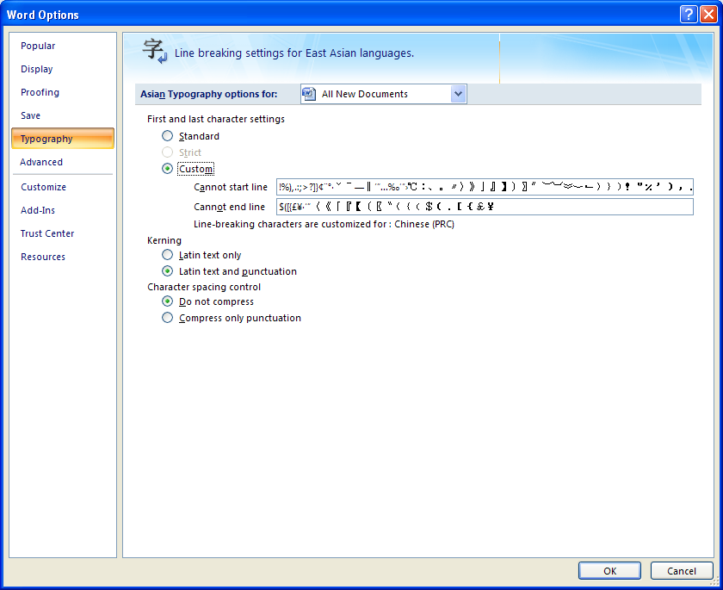

Appendix 2 Page/document format

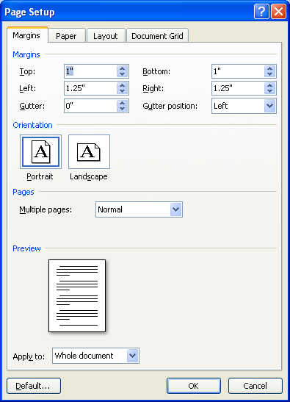

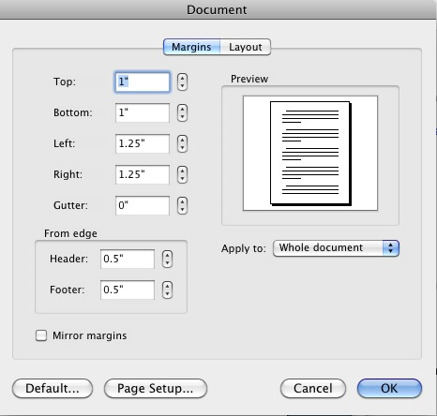

Appendix 3 Paragraph format

For Mac
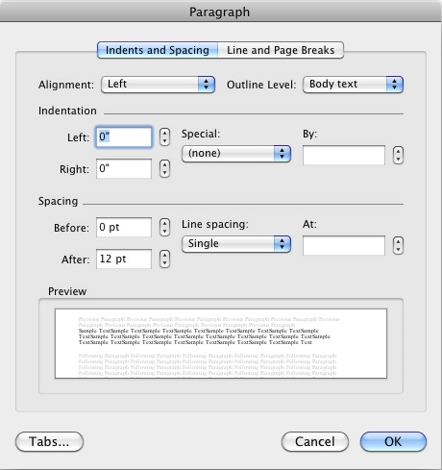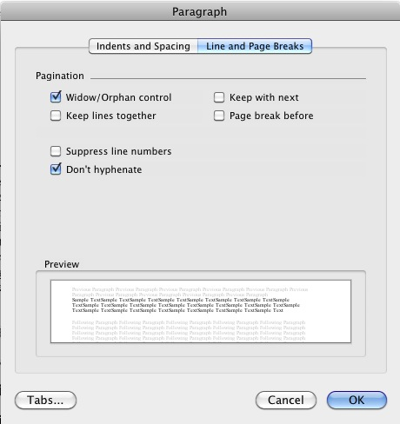

For PC
