Sample of TCLT12 Full Paper Submission in English
(会议论文全文提交英文样本需要中文题目)
Familyname, Firstname
(中文姓名if any)
Example University
(工作单位中文名)
myemail@example.com
Abstract: This is the sample paper in English. If your paper is in Chinese, please refer to the Chinese sample file. The journal publishes articles and reviews in both English and Chinese. English articles should go through a spelling and grammar check on the computer before submission. Authors writing in their non-native language are advised to have their articles thoroughly edited by professionals with native-level proficiency in that language prior to submission. If you use the “Track Changes” feature in Word, be sure to “Accept All Changes in Document” before saving the final document.
摘要：本文件为英文样本。如果您的文章主要用中文写，请参见中文版的样本。
Keywords: TCLT12, Second language acquisition, Technology
关键词：TCLT12会议、二语习得、技术
1. Introduction
This is the first paragraph. The journal publishes articles and reviews in both English and Chinese (Li, 2012; Wang and Li, 2001; Zhang, 2011). English articles should go through a spelling and grammar check on the computer before submission.
2. Literature Review
2.1 Definition
This is the definition. A sample table is given below.
Table 1: This is my first table
aa | Bb | Cc | Cc
11 | 22 | 33 | 44
2.2 John Doe’s research
This is the second paragraph. The journal publishes articles and reviews in both English and Chinese. English articles use Times New Roman (Chen 2012).
3. This Research
3.1 Data collection
This is third paragraph. Authors writing in their non-native language are advised to have their articles thoroughly edited by professionals with native-level proficiency in that language prior to submission.
This is fourth paragraph. Authors writing in their non-native language are advised to have their articles thoroughly edited by professionals with native-level proficiency in that language prior to submission.
3.2 Results
This is another paragraph. The journal publishes articles and reviews in both English and Chinese.
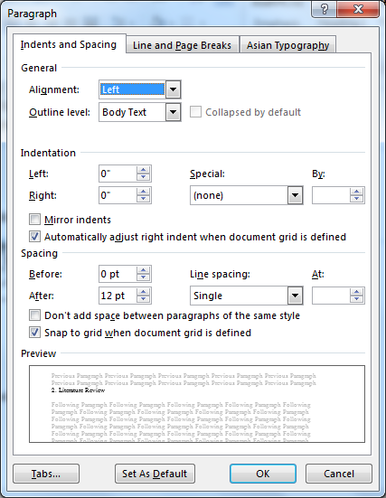
Figure 1: APA: Figure legends are complete sentences, mentioned in the text, and copyright cleared
This is the end of our discussion.
4. Conclusion
This is the conclusion of the paper. The journal publishes articles and reviews in both English and Chinese. English articles should go through a spelling and grammar check on the computer before submission. Authors writing in their non-native language are advised to have their articles thoroughly edited by professionals with native-level proficiency in that language prior to submission.
References
American Council on the Teaching of Foreign Languages. (1996). Standards for Foreign Language Learning: Preparing for the 21st Century. Lawrence, KS: Allen Press, Inc.
Brooks, N. (1968). Teaching culture in the foreign language classroom. Foreign Language Annuals, 1(3), 204-217.

Zhang, S. (2012). Sample paper for TCLT9 on technology. Retrieved from http://www.tclt.us. [张三. (2012). TCLT9会议论文格式的具体描述和参考. 来源: http://www.tclu.us].

Footnote uses Times New Roman as well. Set its size to 10 pt. Do NOT justify.
Here is another footnote for your reference.

