Sample of TCLT Monograph Paper Submission in English
(专辑论文提交英文样本需要中文题目)
Familyname, Firstname
(中文姓名if any)
Example University
(工作单位中文名)
myemail@example.com
Abstract: This is the sample paper in English. If your paper is in Chinese, please refer to the Chinese sample file. Please choose indent 0.5" for both left and right margin. Please use single space and the font Times New Roman 12. Please choose three or four keywords. Please justify the abstract and body text. Please do not add page number for each page.
摘要：本文件为英文样本。如果您的文章主要用中文写，请参见中文版的样本。摘要和正文部分文字两边对齐。文献部分左对齐。选用3-4关键词。每页请不要加页码。
Keywords: Chinese language, Technology, Online, TCLT Monograph
关键词：中文、技术、线上、TCLT专辑
1. Introduction
This is the first paragraph. Please use Times New Roman, font size 12. Indent 0.5" for the first line. The monograph publishes articles in both English and Chinese (Liu, 2018; Xu, 2017; Yin & Hsu, 2017). For the in-text citation, if there are cited works not written in English, please use the Latin alphabet such as Pinyin for the author’s last name, and provide English translation in the Reference section (see the sample for Xu, 2017). For in-text citations involved works written by three authors, such as (Sun et al., 2013；Tseng et al., 2019), please list the first author’s name followed by “et al.” by referring to APA 7.
2. Program Description
2.1 Chinese Program Overview
Authors writing in their non-native language are advised to have their articles thoroughly edited by professionals with native-level proficiency in that language prior to submission. Please leave one line space (12pt) between heading and subheadings. A sample table is given below. Please provide caption for each table. Use font size 10 for the caption and center the text.
Table 1: This is my first table
Aa | Bb | Cc | Cc
11 | 22 | 33 | 44
2.2 Courses Taught Online
This is the second paragraph. English articles use Indent 0.5" for the first line. Please capitalize the subheading for each section (Tseng et al., 2019). For a citated reference with three authors (e.g., Tseng, Gao, Cai) or more, please use et al. for the in-text citation, and list names of all authors in the reference section.
3. Strategies
3.1 Effective Strategies
Please bold and capitalize the headings and subheadings. Please use Times New Roman, font size 12. Indent 0.5" for the first line Please justify the abstract and body text. Please bold and capitalize the headings and subheadings. Below is an example for figures.
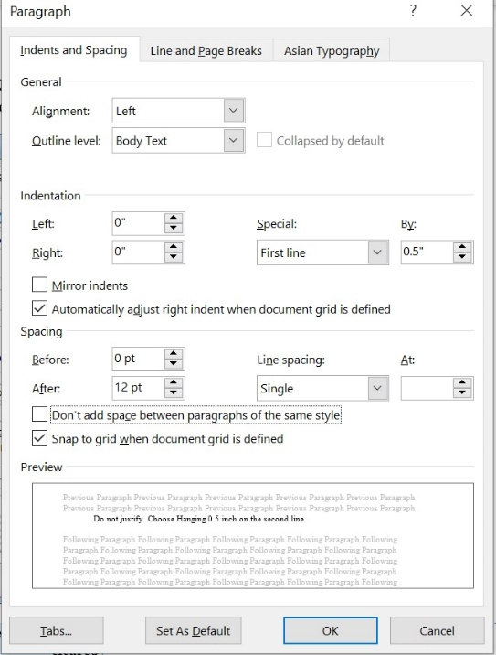
Figure 1: bold, 10pt.
3.2 Plans for Future Teaching
Please use the examples provided in the References sections when formatting your references, including citing book chapters (Sun et al, 2013) and conference presentations (Yin & Hsu, 2017). Please choose hanging 0.5, left alignment and do not justify (Stickler & Shi, 2013). The screenshot below shows the setup for the References section.
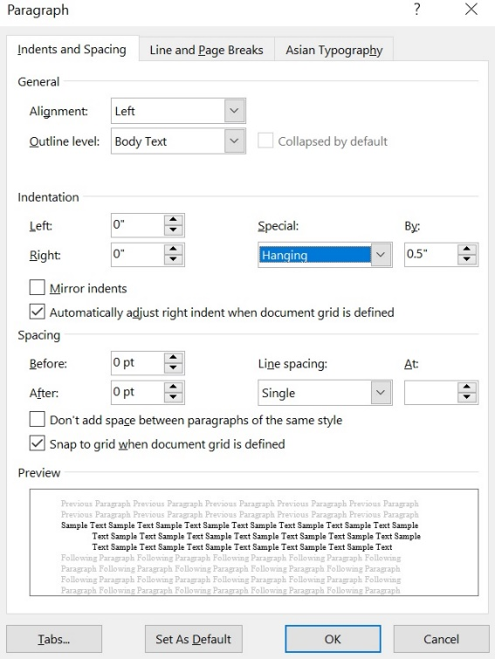
Figure 2: The above figure shows the formatting setup for the reference section.
4. Summary
Please leave 24pt (two lines) between the body text and the References section. Please make sure that each citation mentioned in the abstract or body text is listed in the Reference section and each of the listed references is cited at least once in the body text
References
Liu, S. (2018). Teaching and learning Chinese language online: What and why? International Chinese Language Education, 3(2), 11-26.
Stickler, U. & Shi, L. (2013). Supporting Chinese speaking skills online, System, 41 (1), 50-69. http://dx.doi.org/10.1016/j.system.2012.12.001
Sun, M., Chen, Y., & Olson, A. (2013). Developing and implementing an online Chinese program: A Case Study. In B. Zou, M. Xing, Y. Wang, M. Sun, & C. Xiang (Eds.), Computer-Assisted Foreign Language Teaching and Learning: Technological Advances (pp. 160-187). Hershey, PA: IGI Global. doi:10.4018/978-1-4666-2821-2.ch010
Tseng, M., Gao, Y., & Cai, L. (2019). Enhancing interaction through the effective incorporation of technology tools for a virtual Chinese language classroom. Journal of Technology and Chinese Language Teaching, 10(1), 91-113.
Xu, J. (2017, November 23). iiMedia Research released the “White Report on 2017 Online Education Industry in China”. http://www.iimedia.cn/59799.html [许俊 (2017). 艾媒咨询发布《2017年中国在线教育行业白皮书》. http://www.iimedia.cn/59799.html]
Yin, C. & Hsu, Y. (2017, October). Towards the design of a hybrid advanced Chinese class. Presentation given at the 3rd Online Chinese Teaching Forum and Workshop, Michigan State University, East Lansing, MI.

Footnote uses Times New Roman as well. Set its size to 10 pt. Do NOT justify.
Here is another footnote for your reference.

