This is the Main Title of Your Paper
(文章标题)

Lastname, Firstname
(中文姓名 if any)
Rensselaer Polytechnic Institute
(伦斯勒理工学院)
zhouy12@rpi.edu

Abstract: Existing literature indicates that there is an urgent need both for second language acquisition (SLA) theory informed research in game-based learning (Reinders, 2012) and for vocabulary instruction research with real students in real classrooms rather than in short-term experimental settings (Spada, 2005) …

摘要：现有文献表明目前有两个领域急需研究：一是在二语习得理论指导下的游戏式学习研究(Reinders, 2012)；二是以真实教室真实学生为研究载体，而非在短期试验性环境中进行的词汇教学研究(Spada, 2005)。……

Keywords: Web 2.0 tool, CALL, Chinese vocabulary instruction, language learning games, learning motivation

关键词: 网络2.0工具，电脑辅助语言学习，中文词汇教学，语言学习游戏, 学习动机

2. Literature Review

2.1 Gamification: Promoting Competition and Motivation

Researchers have identified that gamification provides players (learners) with “the sense of engagement, immediate feedback, feeling of accomplishment, and success of striving against a challenge and overcoming it” (Kapp, 2012, p.xxii). Thus, the social dimension of competition-driven educational games motivates students to participate in learning activities, through peer competition (Chen, 2014). Recent research indicated that game competition, especially competitive situation in gamification, motivates students to …

电脑辅助语言学习（Computer Assisted Language Learning，简称CALL）作为一个新兴学科，在第二语言教学方面已经获得了应有的地位。其研究不断兴起，多媒体教学、网路教学也是日新月异。新技术、新软件、新平台更是层出不穷，反过来又进一步促进了电脑辅助语言学习的发展。中文电脑辅助语言学习（Chinese CALL）也同样发展迅速，有关中文电脑辅助语言学习的研究和实践也不断深入开展。中文电脑辅助语言学习的研究与实践与CALL研究是否同步？有无差异和不同？CALL研究经历了哪些阶段，遇到了什么问题？哪些解决了？哪些争端还存在？现在CALL研究的重点是什么？有什么新趋势？为了总结成果、发现问题，进一步推动中文电脑辅助语言学习的全面发展，有必要对CALL的发生、发展、名称和定义、研究方法和理论框架、实践与反思、问题和争论、当前研究重点和发展趋势等做一总结分析，同时与中文CALL相应的方面做比较。这其实也是中文CALL与其他与语种CALL的比较研究。
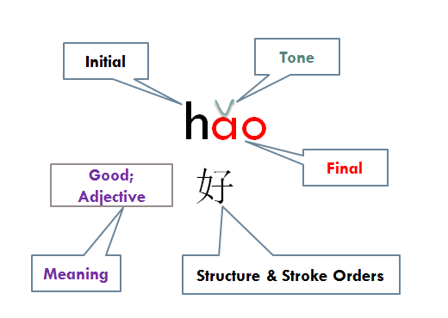
Figure 1: Elements of Learning a New Chinese Word

Table 1: Usefulness of Quizlet and Attitudes Towards Vocabulary Game Competitions
 | Usefulness (%) | Quizlet Game Competition
 |  | Like (%) | Neutral (%) | Do not Like (%)
Spring 2014 | 71.4 | 44.7 | 6.2 | 49.1
Fall 2014 | 93.8 | 68.8 |  | 31.2
Spring 2015 | 88.9 | 77.8 | 10.0 | 12.2

While there are benefits of vocabulary learning through games (gamification), there needs to be continued investigations with real language curricula and more qualitative research because “instructed SLA research carried out in real classrooms with real learners and teachers has a greater potential to inform classroom practice than

Acknowledgements: I would like to express my most gratitude to Dr. Donna Bain Butler and Dr. Lisa Winstead. Their constructive feedback and suggestions are instrumental in revising the early versions of this paper. All errors that remain in the paper are my own.

References

Aghlara, L., & Tamjid, N. H. (2011). The effect of digital games on Iranian children's vocabulary retention in foreign langauge acquisition. Procedia-Social and Behavioral Sciences, 29, 552-580.
You, L., & Wang, S. (2005). Rules and distributions of Chinese verb-verb collocations. Computer Engineering and applications, 23, 179-181. [由丽萍, 王素格. (2005). 汉语动词——动词搭配规则与分布特征. 计算机工程与应用, 23, 179-181.]

